The 16 th International Conference on Industrial Technology Innovation (ICITI, 2015)
Open Data and Government Innovation
Date 3-4, September

Taiwan Institute of Economic Research (TIER) and its partners organize this conference once a year since year 2000. Over the last 16 years, with the continuous support from Department of Industrial Technology (DOIT) under the Ministry of Economic Affairs (MOEA), this event gradually builds up its international reputation and connections, and has become one of the most important of its kind.
This year, the conference agenda is “government innovation and open data”. Recently “Industry 4.0 and Smart Manufacturing“ probably are the two most heard of buzzed words in the industrial and innovation policy communities around the globe. In Taiwan, the equivalent is “productivity 4.0”.
These concepts are meant to assist us designing better and smarter policy to improve productivity, and to bring values to the society as a whole. However, if we really like to achieve this goal, the government must also upgrade its mindset and its way of doing things to “Government 4.0”. That means the government needs to play smarter, and to take a more proactive approach to innovate itself, in order to be compatible with the fast-moving private sector.
The Era of Big Data and Open Data is presenting a set of good opportunities for government innovation. Many tools and data which are valuable and useful to the industry, are now also available to the government. The government should take these emerging opportunities, and make the most of these tools and data to deliver better public services.
Making the government more proactive and innovative is not an easy task, especially in an age of austerity. It requires a great deal of effort. Many critical issues and elements should be taken into account. Many wicked problems need to be solved as well. This is also the reason for why we have this conference.
This year, we invite seven remarkable speakers from the UK, South Korea, Sweden and Taiwan to share their valuable knowledge and experiences in relation to “government innovation and open data”. We also invites a group of high-ranking official guests from Indonesia, South Korea, Malaysia, Myanmar, Peru, the Philippines, Thailand and Vietnam. This conference encourages everyone to participate and initiate dialogue more actively! We believe lively conversation and idea-exchange is the mother of all kinds of innovation. So let’s try to practice it in this two-day event, and make this conference a great international forum to innovation policy communities around the globe.

2015-09-03 (Thursday)
Time | Session
0900:-09:30 | Registration
09:30-09:40 | Opening and Moderator Remark  Dr. Chien-Fu Lin, President of Taiwan Institute of Economic Research
09:40-10:30 | Data, experiment, judgement - new approaches to innovation policy  Stian Westlake, Executive Director of Policy and Research, National Endowment for Science, Technology and the Arts (NESTA), UK
10:30-10:40 | Q&A
10:40-11:00 | Coffee Break
1100:-11:50 | Using Open Data for Social Good  Lessons from the Open Data Challenge Series  Edward Parkes, Senior Programme Manager, NESTA, UK
11:50-12:00 | Q&A
12:00-13:30 | Lunch
13:30-13:40 | Moderator Remark  Chau-Chyun Chang, Deputy General Director, Industrial Economics & Knowledge Center (IEK) of Industrial Technology Research Institute (ITRI)
13:40-14:30 | How to make Smart City a Reality  Hwang, Jong-Sung, Vice President, National Information Society Agency, South Korea
14:30-14:40 | Q&A
14:40-15:00 | Coffee Break
15:00-15:50 | The industry paradigm shift in the era of Data-driven Economy  Tsu-Yu Chao , Deputy Director, Interdisciplinary Research Group, IEK of ITRI
15:50-16:00 | Q&A
16:00-16:20 | Coffee Break
16:20-17:10 | How to design an innovation agency: insights and lessons from around the world  Alex Glennie, Principal Researcher, NESTA, UK
17:10-17:20 | Q&A

2015-09-04 (Friday)
09:30-09:40 | Moderator Remark  Professor Chin-Tay Shih, College of Technology Management & Morris Chang Chair Professor, National Tsing Hua University
09:40-10:30 | Linear versus Holistic Innovation Policies: the Role of the Public Sector  Professor Charles Edquist, Center for innovation, research and Competence in the Learning Economy(CIRCLE), Lund University, member of Swedish Innovation Council
10:30-10:40 | Q&A
10:40-11:00 | Coffee Break
11:00-11:50 | Post Catch-up Development and the Role of the Public sector in Fostering Systemic Innovations  Shin-Horng Chen, Director of International Division, Chung-Hua Institution for Economic Research
11:50-12:00 | Q&A
12:00-13:30 | Lunch
Round Table
13:30-13:40 | Moderator Remarks：  Professor Kung Wang, Department of Business Administration, China University of Technology
13:40-14:30 | Round Table Discussion：  In this session, the floor is open to the audience; we encourage you sharing experience and opinion with regard to the following issues.  - Public Sector Innovation  How to catalyst more government innovation? What has to be changed in the government? What elements or factors are crucial to successfully deliver government innovation?  - Open Data for Innovation  Except making data more transparent and open, how can we better utilize data to deliver social good rather than just commercial values? How can the government play a more proactive role in the era of Open Data?
14:30-15:00 | Networking and End of Conference  You can also tell us your idea about how can we better run this conference and what agenda is worth-covering next year.
Guest Speaker

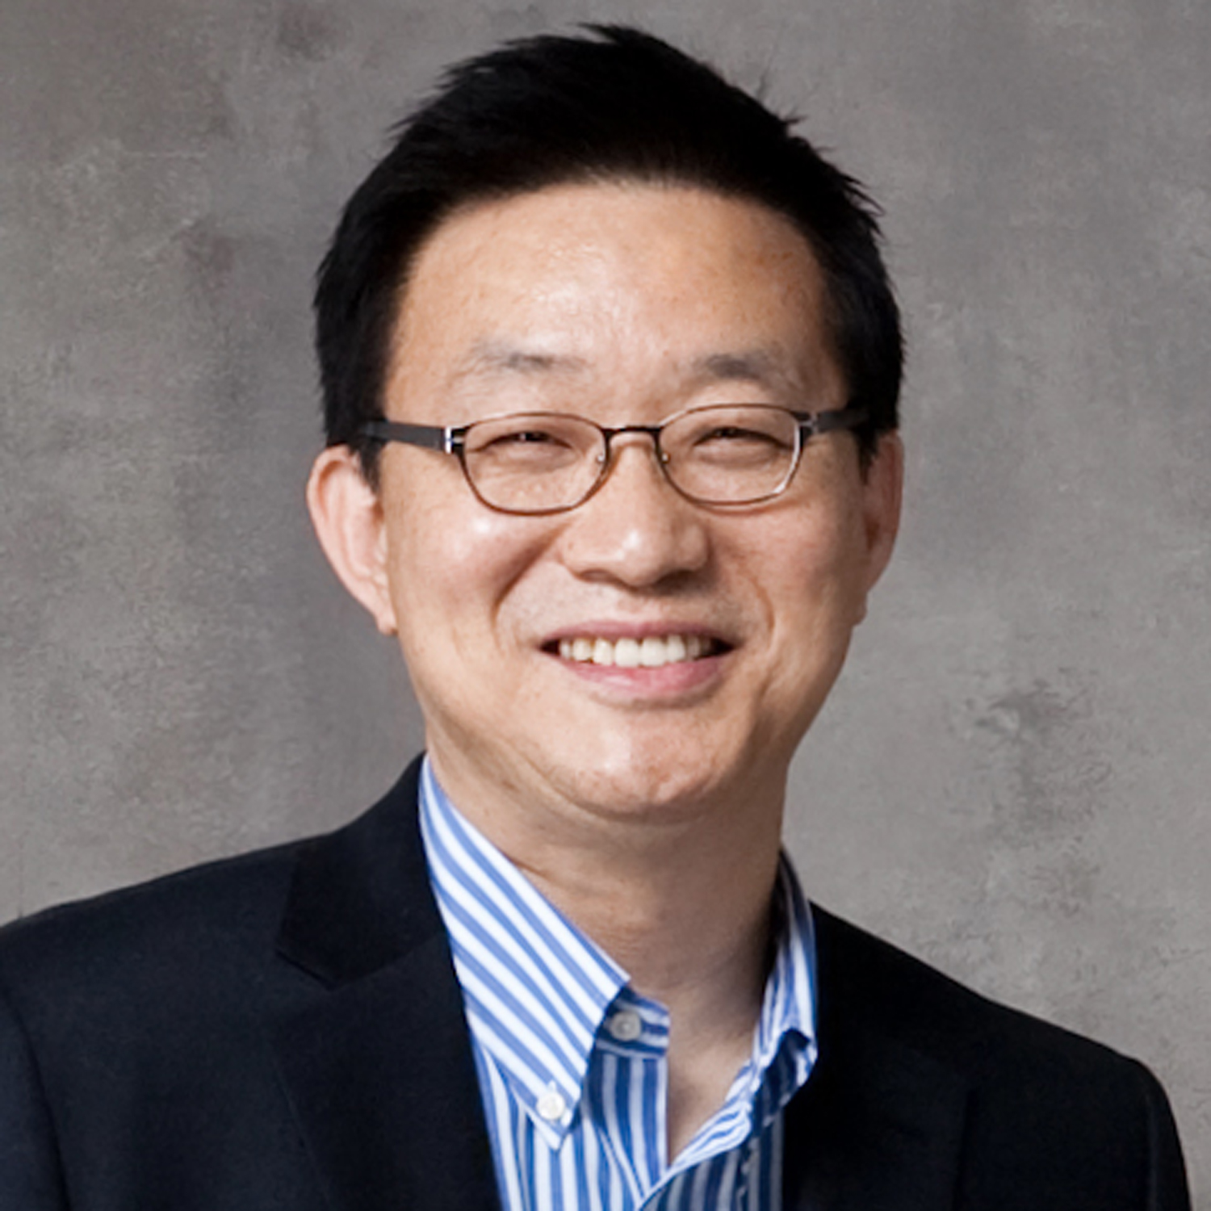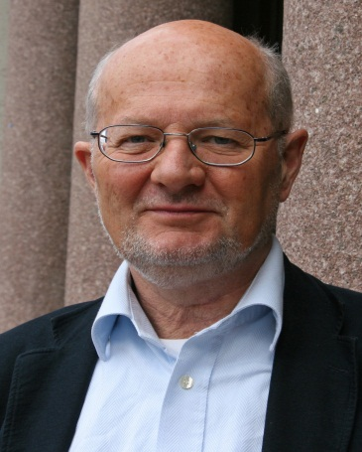
Charles Edquist
Professor Lund University
Member of the Swedish National Innovation Council


Stian Westlake
Executive Director of Policy and Research, NESTA

Edward Parkes
Senior Programme Manager, NESTA

Hwang, Jong-Sung
Vice President, National Information Society Agency

Alex Glennie
Principal Researcher, NESTA

Venue

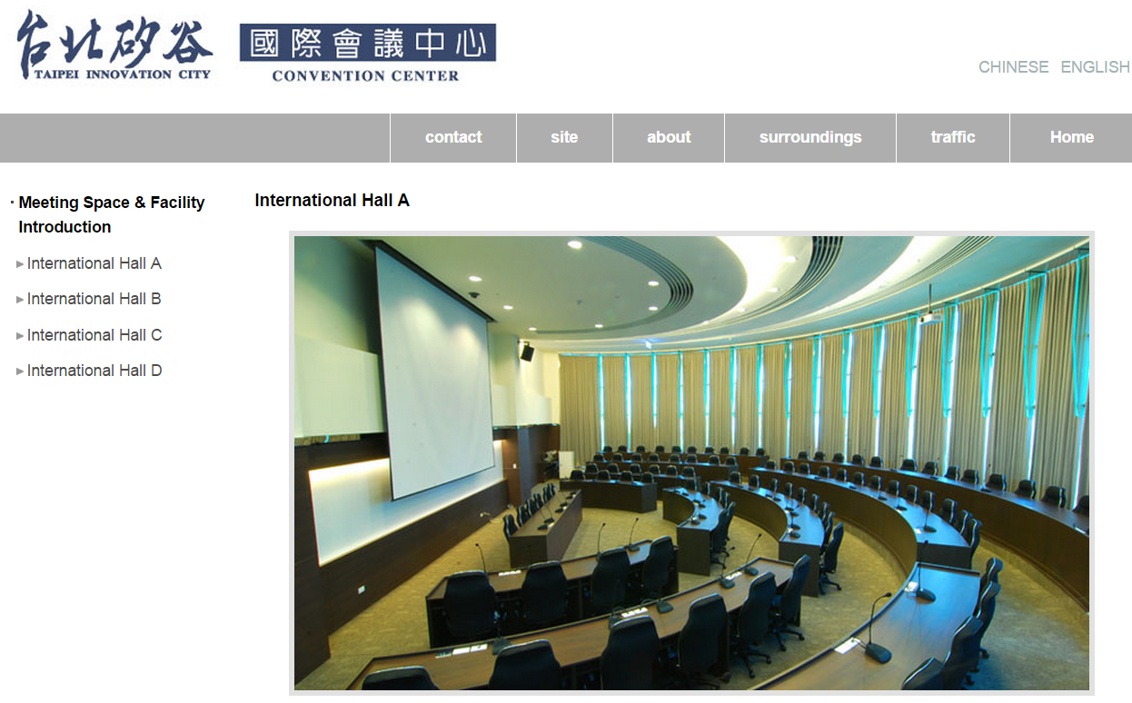

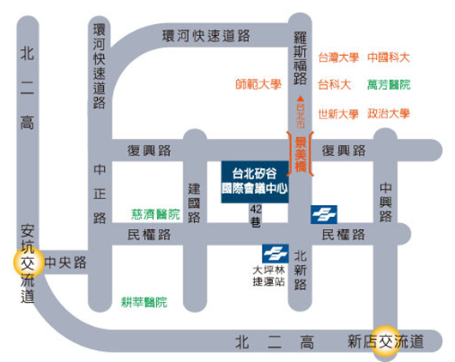

For Traffic Information in English, Please click below
http://www.kticc.com.tw/e_traffic.html

